Pointers on Using the Interclub Snooker App (Mobile Friendly)

A quick phone friendly guide for signing in, following your team, picking lineups, and entering match scores and breaks.

What this guide covers
- How to sign in or activate an account from an invite.
- What players see on the home page during the season.
- How managers pick and publish a team lineup.
- How managers enter scores and record breaks on match night.
- Where to find fixtures, tables, player stats, club bookings and competitions.

Role summary
Role | What you can do
Player | View your team, fixtures, tables, personal stats and match details when active.
Manager | Everything a player can do, plus pick lineups, publish teams, enter scores and record breaks.
Club member | Book club tables, enter competitions, and view club information.

Signing in
The app is invite only. You cannot create a new account unless an administrator has set you up first.
- Open interclubsnooker.com on your phone.
- Use your email and password, or Sign in with Google if your account is connected to Google.
- If you received an activation email, tap the activation link first, set your password, and then continue into the app.
- After login, choose your season and role if more than one is available.
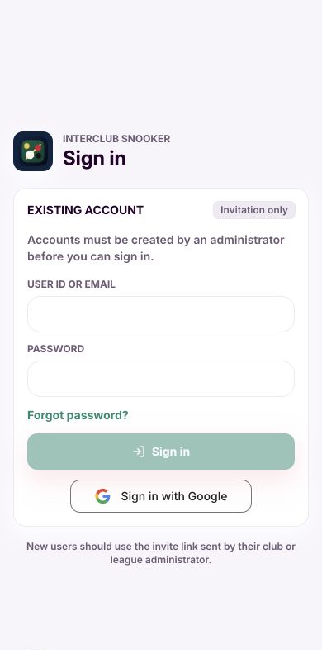
Sign in page for existing users
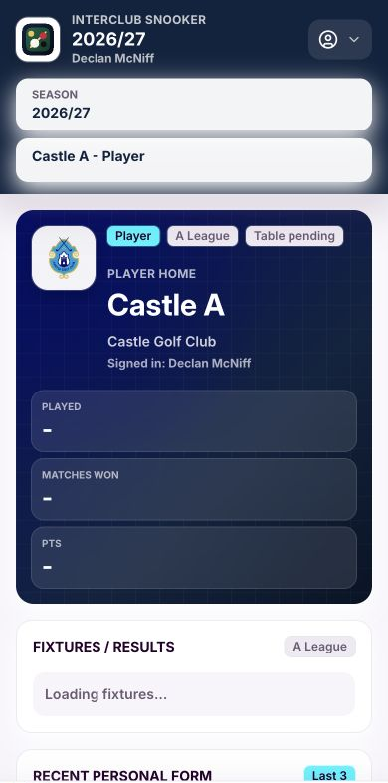
Player home after signing in

Home page basics
The home page changes depending on your role. Most players will have one role and will not need to switch. If you have more than one role, use the role selector at the top of the page.
- Players see their team, their league position, fixtures and results, personal stats and club options.
- Managers see their team view first, including the next match, squad information and scoring tools.
- Club members see club options such as bookings and competitions without interclub match tools.
Tip. When you move between bottom menu tabs, the screen should reset to the top of the selected page.

Following fixtures and results
The fixtures panel is arranged week by week. Use the arrows to move between weeks. Your team match is highlighted when it appears in the week.
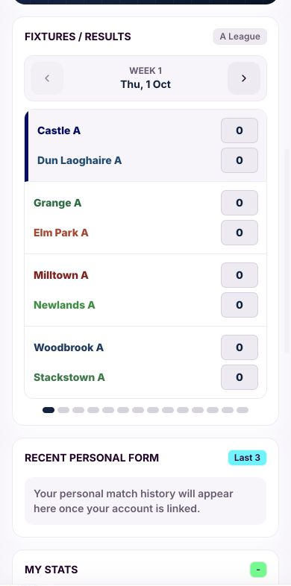
Weekly fixtures and results view

Picking a team as manager
Only managers and assistant managers can pick lineups. Players can see friendlies or match details only when their team is involved, but they cannot create or edit them.
- Go to Fixtures or the next match area on Home.
- Open your team match.
- Tap Pick team if the lineup has not been published.
- Tap each slot and choose the player for that position.
- Save draft if you are not ready. Publish lineup when it is final. A published lineup is locked.
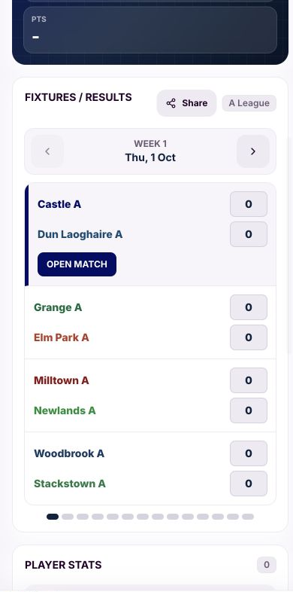
Manager fixture panel before team selection
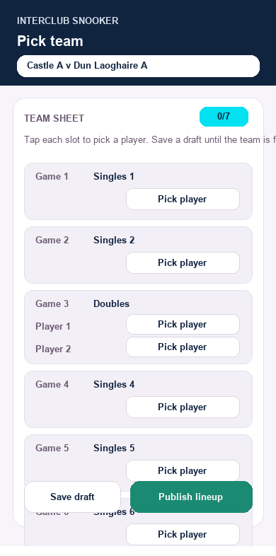
Team sheet with match positions

Choosing players
The player picker is designed for mobile. Tap the position, choose the player, then continue down the list.
- In league matches, a player can only be selected once in the lineup.
- In friendlies, a player may be used more than once if needed.
- The C League format is singles in games 1, 3 and 5, with doubles in games 2 and 4.
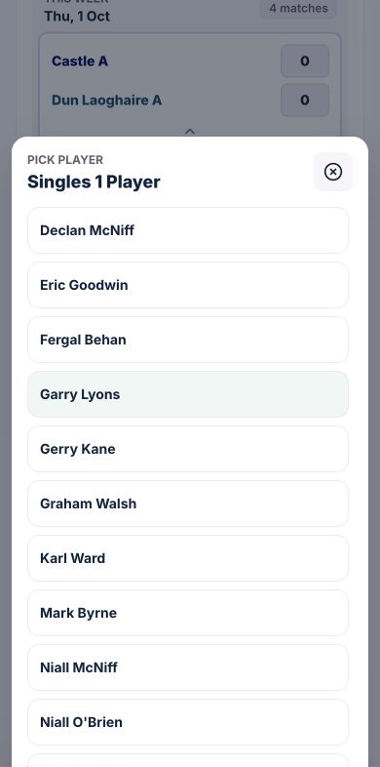
Player picker for one lineup slot
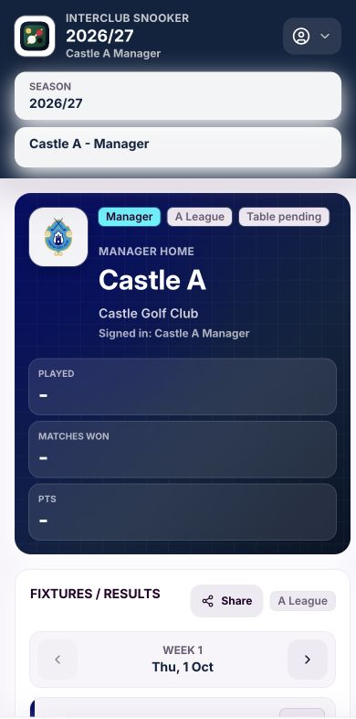
Manager home and season selector

Entering scores on match night
When both teams have published lineups, the match becomes the focus. Managers can enter results game by game. Players can view active match details but cannot edit scores.
- Open the match from Fixtures or Home.
- For each game, tap the winning team or player side.
- Check the running score after each game.
- When all games are correct, press Match Completed. After that, the match is locked.
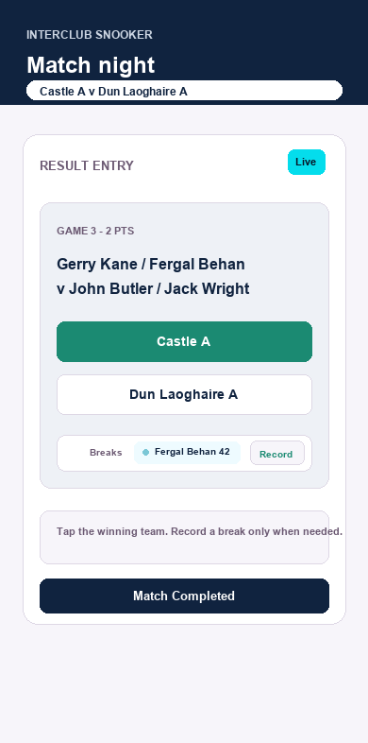
Simple score entry during a match

Recording a break
Most games will not need a break recorded. If there is a break worth recording, use the break entry from the relevant game.
- Open the active match.
- Tap Record break on the correct game.
- Choose the player and enter the break value.
- Save the break. It will be linked to that player and that game.
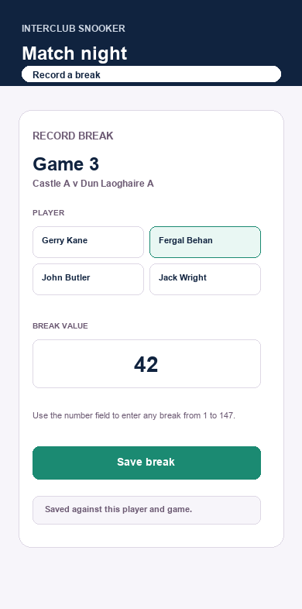
Break entry for a player in a game

Information available all season
The app keeps the key league information close to the home page. Players and managers can see different levels of detail, but everyone should be able to get to the main season information in one or two taps.

League tables
The Tables tab shows your league first, followed by the other leagues. Qualification positions are highlighted according to the league size.
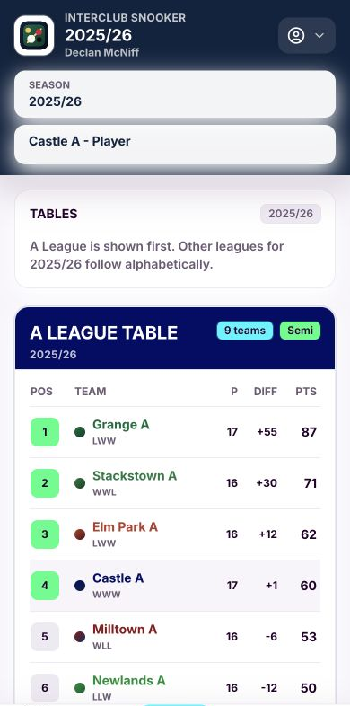
League tables screen

Player stats and breaks
Player stats are season based. If a player did not play in that season, they should not appear in that season stats table. Breaks recorded against games also feed into the player record.
- Personal win rate, played, won and lost are shown for the selected season.
- Highest break appears when a player has a break recorded for that season.
- Doubles games count towards individual player stats for both doubles partners.
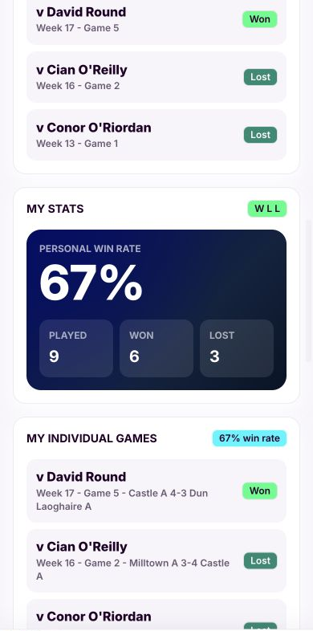
Player stats and personal form

My Club
The My Club tab keeps club functionality separate from interclub duties. This is where club bookings, club competitions and club games live.
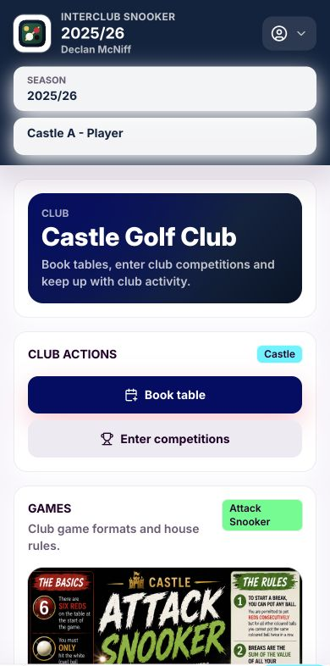
My Club page with bookings and competitions

Quick checklist
When | What to check
Before match night | Confirm your role, team, fixture and selected season.
Manager before match | Pick the lineup, save draft if needed, then publish when final.
During match | Enter each game result and record any meaningful breaks.
After match | Review the score and press Match Completed when everything is correct.
Any time | Use Fixtures, Tables, My Club and stats to follow the season.

A final note
The app is built around roles. A person can be a player in one team and a manager in another. Table bookings and club competition entries are attached to the person, so they still belong to the same individual even when they switch role views.

